AI Assisted Coding Lab 11.4
Name: B.Dhanush
2303A52472
Batch:42
Task 1: Stack Implementation for Undo Operations (LIFO)
Scenario:
You are building a text editor where users can undo their recent actions (typing, deleting, formatting). Each action must be reversed in Last-In-First-Out (LIFO) order
Prompt: Stack Implementation for Undo Operations (LIFO)
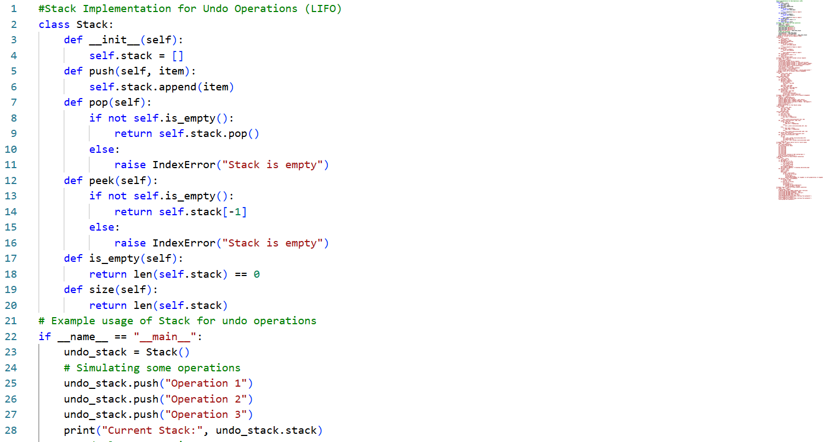
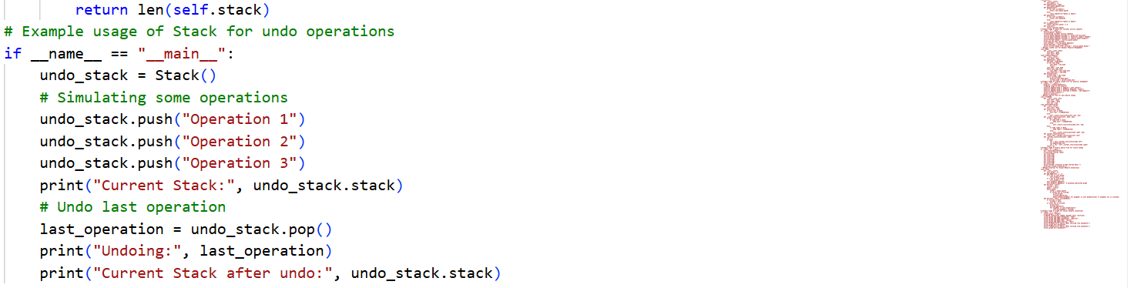
OUTPUT:
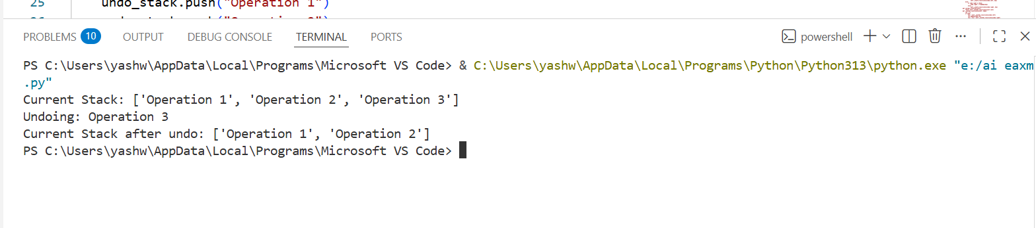
Task 2: Queue for Customer Service Requests (FIFO)
Scenario:
You are developing a customer support system where service requests must be handled in the order they arrive.
Prompt: Queue for Customer Service Requests (FIFO)
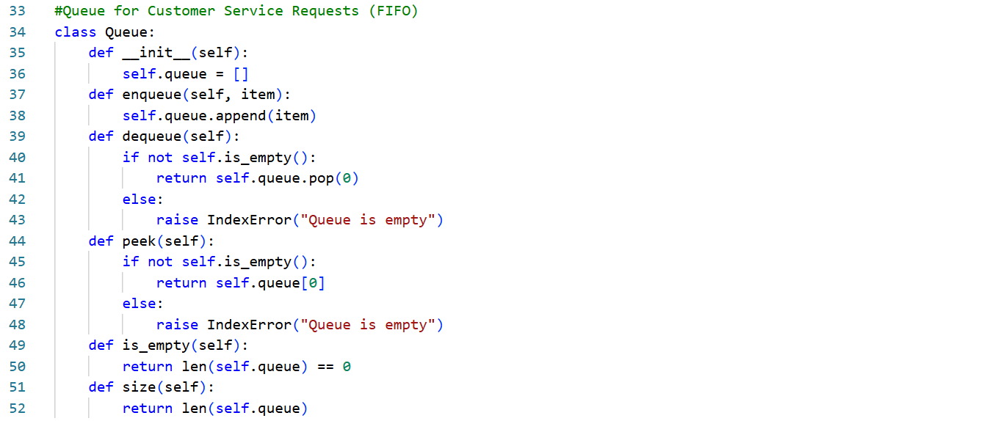
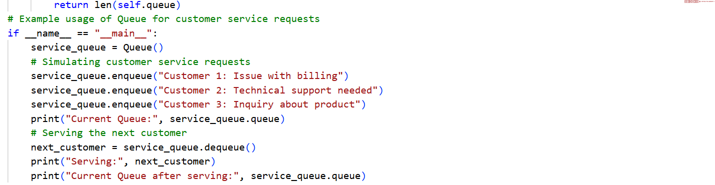
OUTPUT:
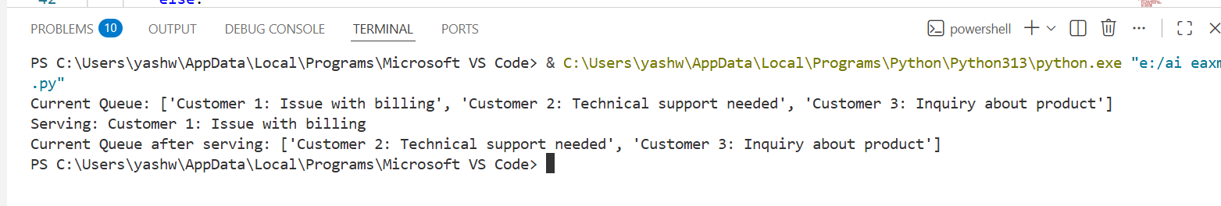
Task 3: Singly Linked List for Dynamic Playlist Management
Scenario
You are designing a music playlist feature where songs can be added or
removed dynamically while maintaining order.
Prompt: Singly Linked List for Dynamic Playlist Management
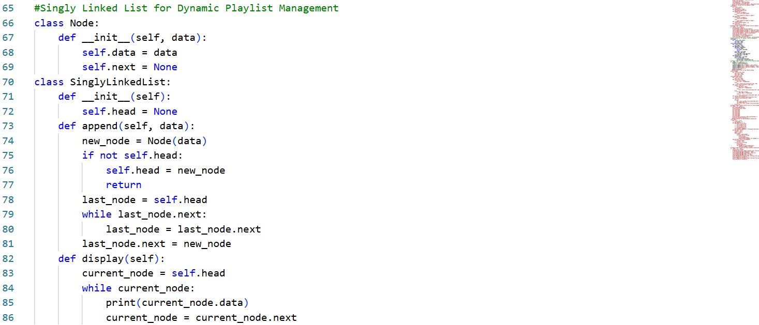

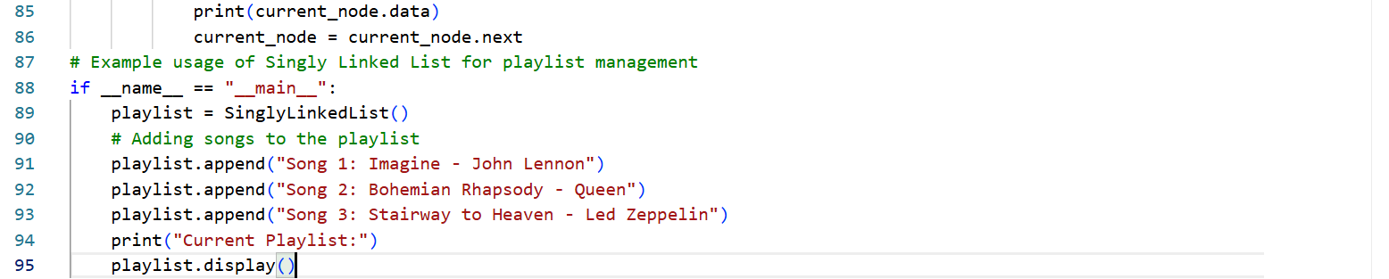
OUTPUT:
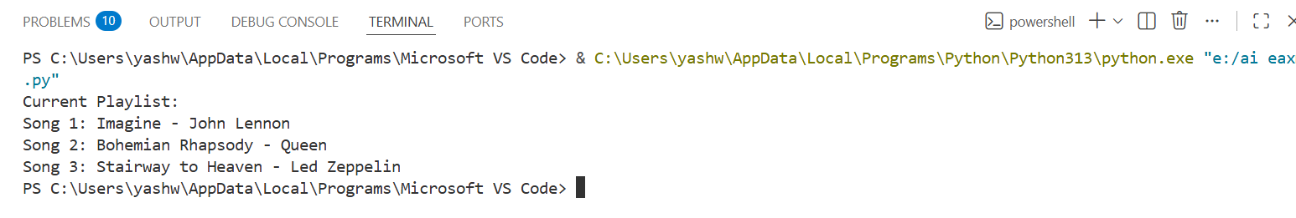

Task 4: Binary Search Tree for Fast Record Lookup
Scenario:
You are building a student record system where quick searching by roll
number is required.
Prompt: Binary Search Tree for Fast Record Lookup
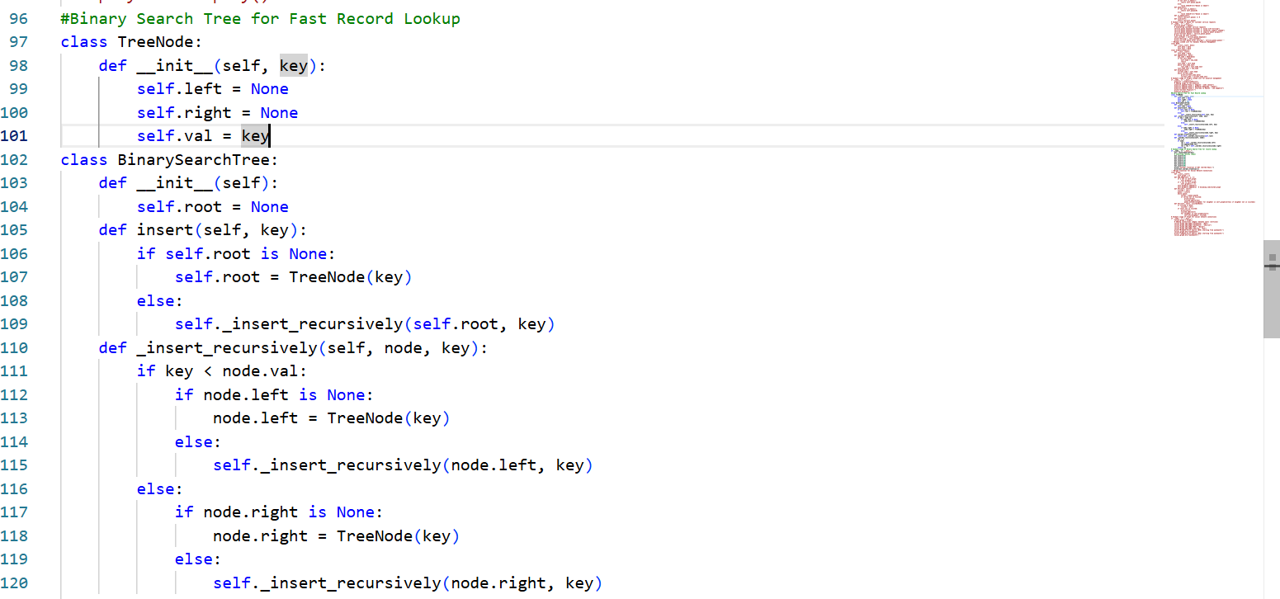
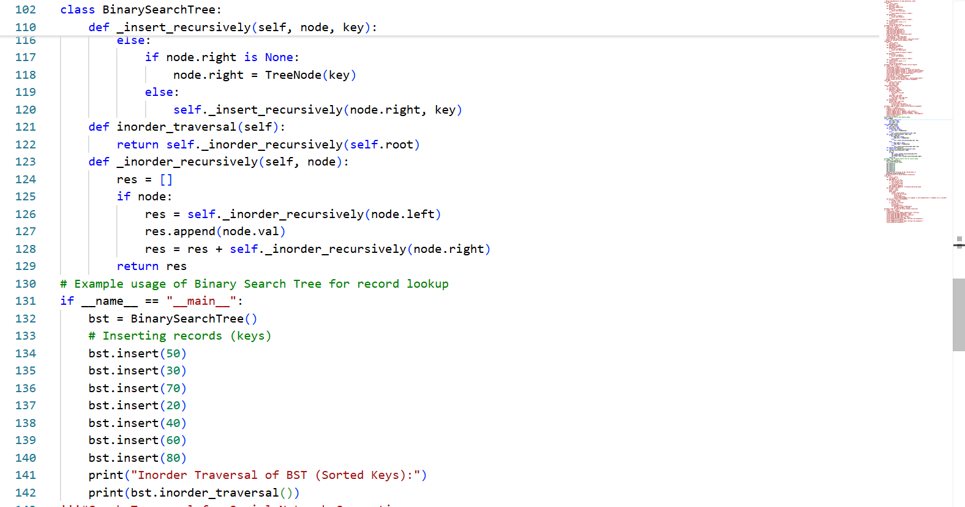
OUTPUT:
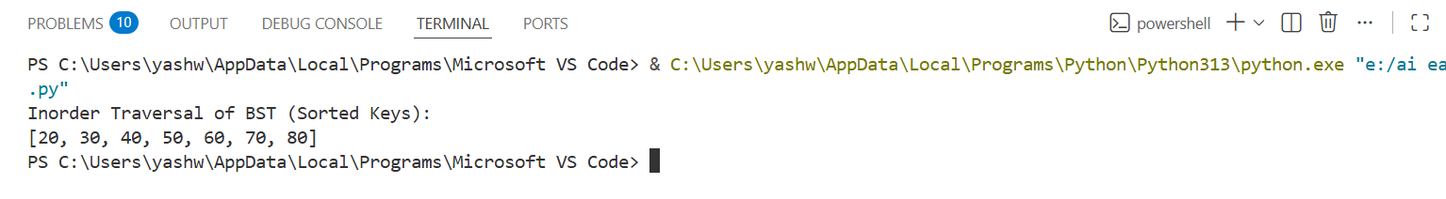
Task 5: Graph Traversal for Social Network Connections
Scenario:
You are modeling a social network, where users are connected to friends, and you want to explore connections.
Prompt: Graph Traversal for Social Network Connections
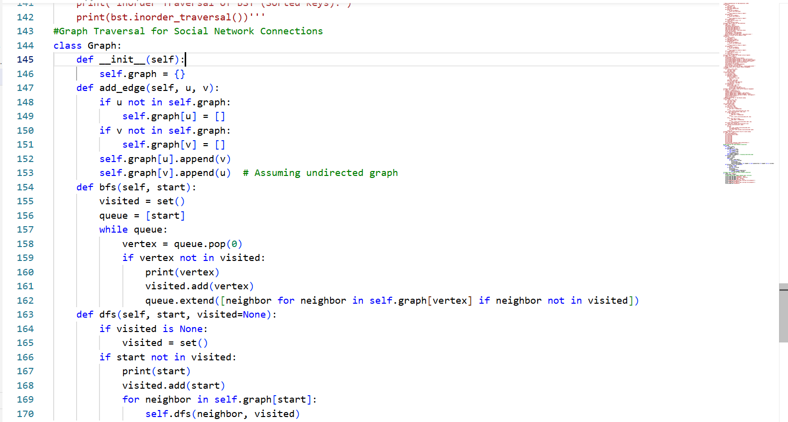
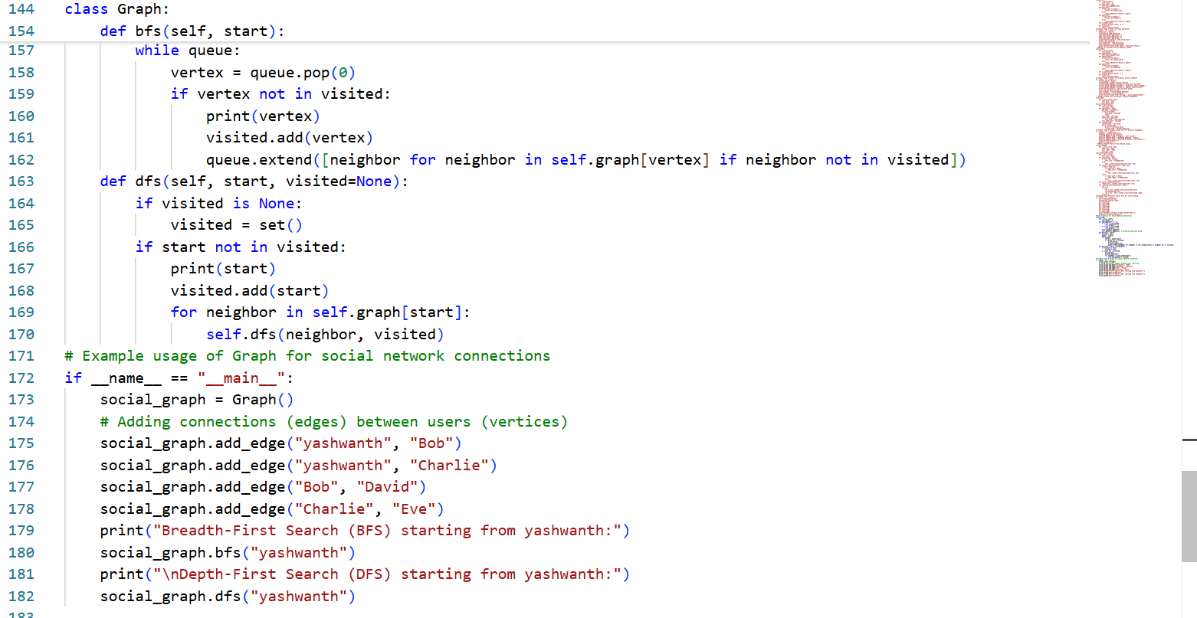
OUTPUT:
